**Experiment no**: 02

**Experiment name**: Observation of Matrix operations in MATLAB

## **Objective**: To perform matrix additions, subtractions and multiplications in MATLAB

**Software Requirement**: MATLAB 2014

# Theory:

### Matrices

The MATLAB environment uses the term matrix to indicate a variable containing real or complex numbers arranged in a two-dimensional grid. An array is, more generally, a vector, matrix, or higher dimensional grid of numbers. All arrays in MATLAB are rectangular, in the sense that the component vectors along any dimension are all the same length.

### Adding and Subtracting Matrices

Addition and subtraction of matrices is defined just as it is for arrays, element by element. Adding A to B, and then subtracting A from the result recovers B:

A = pascal(3); B = magic(3); X = A + B

|  |  |  |  |
| --- | --- | --- | --- |
| X = |  | | |
|  | 9 | 2 | 7 |
|  | 4 | 7 | 10 |
|  | 5 | 12 | 8 |
| Y = X - A | | | |
| Y = |  |  |  |
|  | 8 | 1 | 6 |
|  | 3 | 5 | 7 |
|  | 4 | 9 | 2 |

Vector Products and Transpose

A row vector and a column vector of the same length can be multiplied in either order. The result is either a scalar, the inner product, or a matrix, the outer product :

u = [3; 1; 4];

v = [2 0 -1];

x = v*u

x =

2

X = u*v

X =

|  |  |  |
| --- | --- | --- |
| 6 | 0 | -3 |
| 2 | 0 | -1 |
| 8 | 0 | -4 |

Transposition turns a row vector into a column vector:

x = v'

x =

2

0

-1

If x and y are both real column vectors, the product x*y is not defined, but the two products

x'*y and

y'*x

are the same scalar. This quantity is used so frequently, it has three different names: inner product, scalar product, or dot product.

### Multiplying Matrices

Multiplication of matrices is defined in a way that reflects composition of the underlying linear transformations and allows compact representation of systems of simultaneous linear equations. The matrix product C = AB is defined when the column dimension of A is equal to the row dimension of B, or when one of them is a scalar.

MATLAB uses a single asterisk to denote matrix multiplication. The next two examples illustrate the fact that matrix multiplication is not commutative; AB is usually not equal to BA:

X = A*B

X =

15 15 15

26 38 26

41 70 39

Y = B*A

Y =

15 28 47

15 34 60

15 28 43

A matrix can be multiplied on the right by a column vector and on the left by a row vector:

u = [3; 1; 4];

x = A*u

x =

8

17

30

v = [2 0 -1];

y = v*B

y =

12 -7 10

### Identity Matrix

Generally accepted mathematical notation uses the capital letter I to denote identity matrices, matrices of various sizes with ones on the main diagonal and zeros elsewhere. These matrices have the property that AI = A and IA = A whenever the dimensions are compatible. The original version of MATLAB could not use I for this purpose because it did not distinguish between uppercase and lowercase letters and i already served as a subscript and as the complex unit. So an English language pun was introduced. The function

eye(m,n)

returns an m-by-n rectangular identity matrix and eye(n) returns an n-by-n square identity matrix.

### Lab Tasks:

1. Execute addition and subtraction of matrics

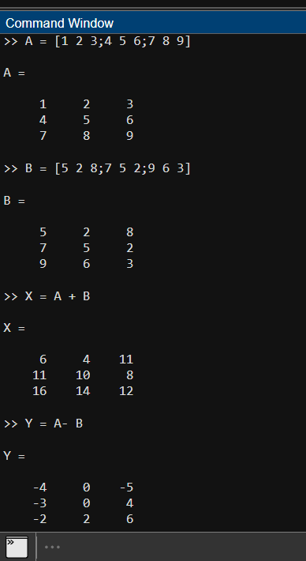

1. Execute multiplication of matrics

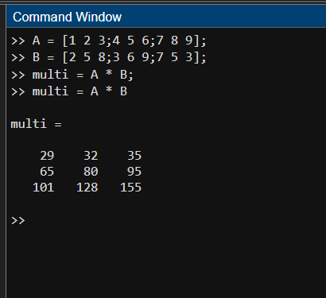

1. Find out INVERSE MATRIX of Your Input A Matrix.

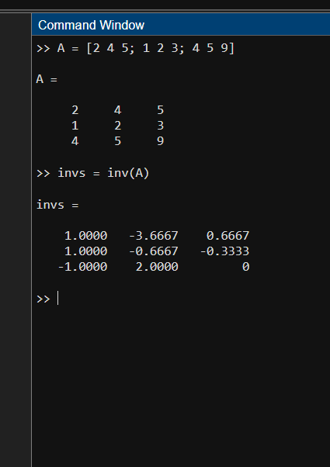

# Discussion:

## In this lab, we focused on matrix implementation and key operations—addition, subtraction, multiplication, and inversion. The hands-on exercises, executed error-free, demonstrated proficiency in utilizing MATLAB for efficient matrix manipulations. This foundational understanding lays the groundwork for applying matrices in various mathematical and engineering applications.